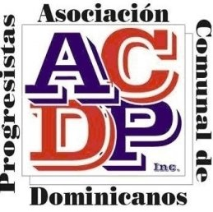

A Community School Program establishes connections with lead Community Based Organization and the school, to support and deliver internal and external partnerships that supports the whole child and integrates a focused effort on supporting attendance, academics, health and social services, after school and community engagement. This partnership leads to improved student learning, stronger families and healthier communities. Wellness and integrated student supports, and expanded learning time.

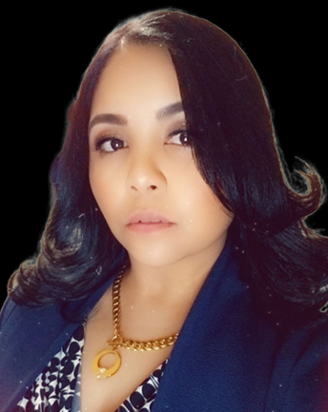
Rosa Rojas

ACDP-Community School Director I work in collaboration with the school Principal, SLT, Parent Coordinator, and Family Outreach Specialist, to implement a model of family engagement that creates strong school-to-home partnerships that cultivates families as leaders in the school. In the creation of events, such as community school forums, develop strong relationships with stakeholders and ensure they understand what a community school is and how it supports student achievement. Serve as a point person for coordinating vision screenings, mental health services and physical health services. Build relationships and mechanisms to effectively link the school day to expanded learning activities. Serve as a key member on the school’s attendance team, including using data tools such as New Visions Data Portal and DOE Insight for tracking and coordinating student interventions.

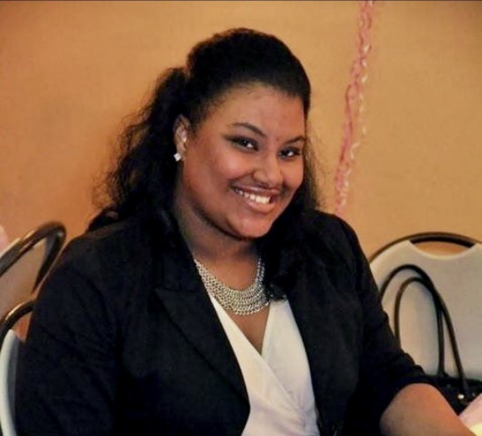
Michelle Lajara

As the Community School Assistant Director, I work under the directives of the CSD by supporting services, communication, attendance and operation of the community school strategy, including building and maintaining relationships with school and outside administration, faculty, staff, students, and families strengthening, and maintaining the bridge between the school, CBO and the school community.

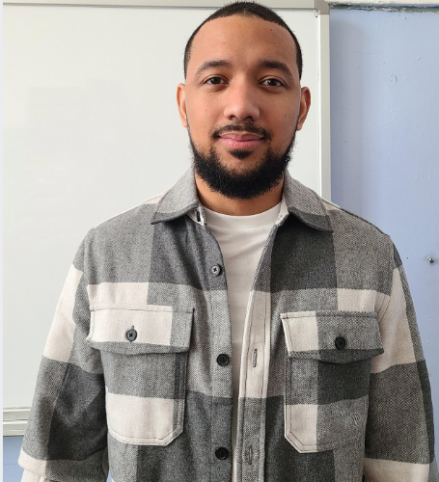
Juan Gutierrez
As the Community School Extended Learning Coordinator I arrange, plan and implement the ELT program for ACDP, Community School at P.S.11x. Responsible for planning activities, ensuring safety of all children in the program, serving snacks, interacting with children and their families, working independently as well as with the team under its supervision, and creating an enriching, fun, and safe environment. Reports back to the Program Director to make sure all aspects of the program are covered and supported.
Community School Contact information
Rorojas@acdp.org / Rrojas12@schools.nyc.gov
Mlajara@acdp.org
Jugutierrez@acdp.org

